2019.10.18

Administration>Customer Management> Reward Point Management

Development required

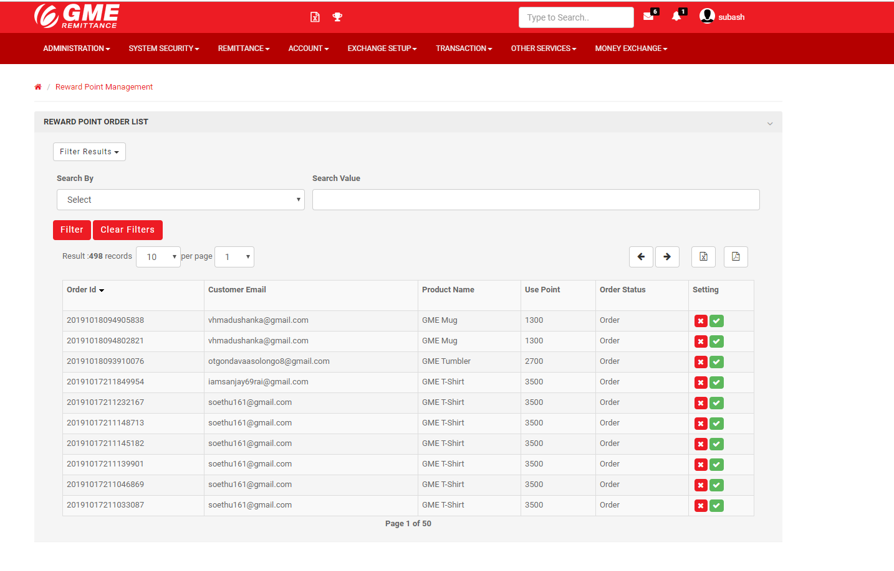

Reward Points Setup

Redeemed Date

Reward Point redemption report

Order Status Filter( dropdown menu)

Reward points Statement

Reward Point Order List

Order Date

Requested Branch

Branch Filter( drop down menu)

In the Second Tab “Reward Points Statement”



User Name *( placeholder)*

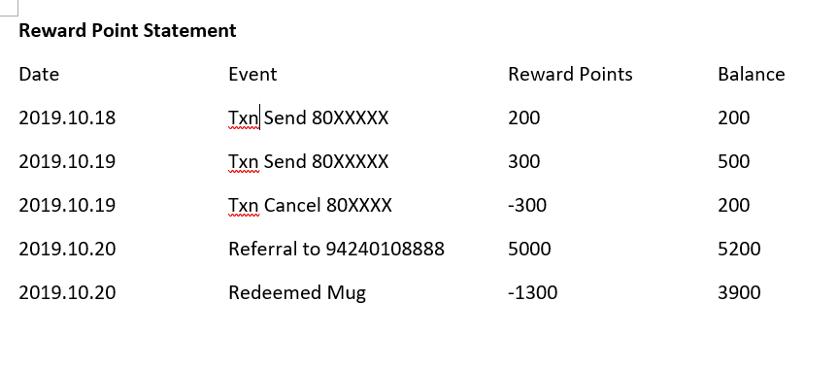

In the Third Tab “Reward Point redemption report”

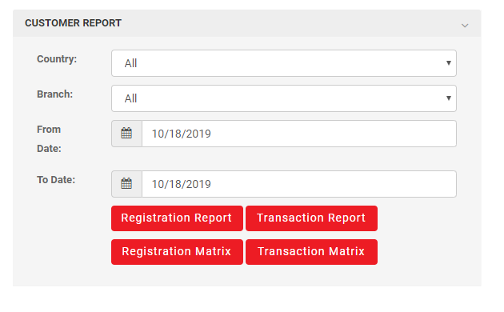

Redemption Matrix

Redemption Report

Reward Point Redemption Report

1. If Clicked Redemption Report the report in following format should appear

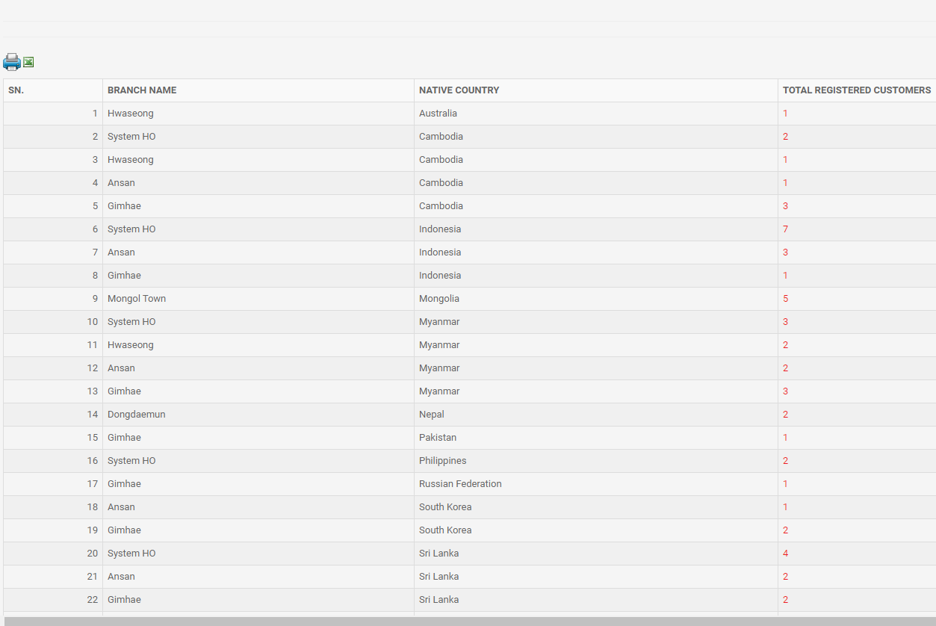

Total Gifts Redeemed

Gift Type

1. If clicked on Redemption Matrix, the following report

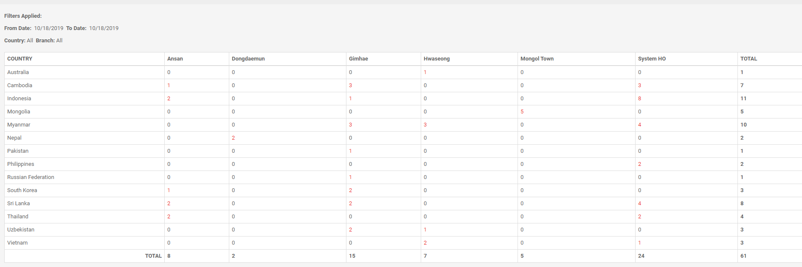

Gift Type

Mug

T-Shirt

…..

In the Fourth Tab “Reward Points Setup”

**Reward Points Setup**

Reward Item( Display Name) Image Points Required to Redeem

Browse

GME Mug 1300

The Four Tabs should be separately right controlled from the “Role setup” Menu